**Experiment – 2.2(b)**

**Student Name: Milan Sharma UID: 23MAI10003**

**Branch: ME – CSE - AIML Section/Group: MAI – 1 (A)**

**Semester: 1st Date of Performance: 11 Oct 2023**

**Subject Name: Python Programming Subject Code: 23 CSH 623**

1. **Aim of the Experiment :**

Write a python program to traverse, add, delete and replace item in dictionary.

1. **Objective of the Experiment :**

To traverse, add, delete and replace item in dictionary.

1. **Algorithm/ Steps for Experiment**

In Python, a dictionary is an unordered sequence of data entries that can be used to record data entries in the same way that a map can.. Following are the steps-

1.        Initialized a dictionary

2.         Give initial values

3.         Add or Remove element or data

4.         If traverse then go from one end to other end

5. Print the dictionary

**For Adding new data -**

**Code for Experiment :**

Dictionary = {}

print("The empty Dictionary: ")

print(Dictionary)

Dictionary[0] = 'Javatpoint'

Dictionary[2] = 'Python'

Dictionary.update({ 3 : 'Dictionary'})

print("\nDictionary after addition of these elements: ")

print(Dictionary)

Dictionary['list_values'] = 3, 4, 6

print("\nDictionary after addition of the list: ")

print(Dictionary)

Dictionary[2] = 'Tutorial'

print("\nUpdated dictionary: ")

print(Dictionary)

Dictionary[5] = {'Nested_key' :{1 : 'Nested', 2 : 'Key'}}

print("\nAfter addtion of a Nested Key: ")

print(Dictionary)

**Result/Output :**

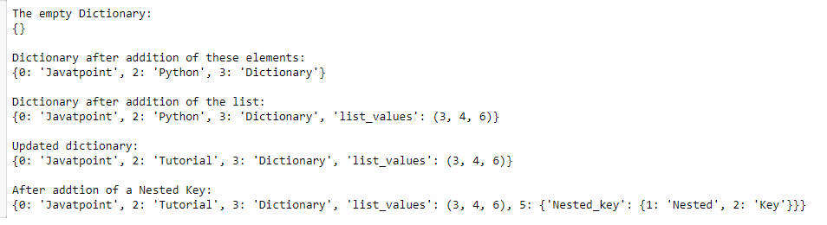

**For Removing the data -**

**Code for Experiment :**

# initializing a dictionary

Dictionary = {1: 'a', 2: 'b', 3: 'c', 4: 'd', 5: 'e'}

# removing a key:value pair from the dictionary using pop()

Dictionary.pop(4)

print("\nAfter removing a key using pop(): ")

print(Dictionary)

# remove any item at random using popitem()

Dictionary.popitem()

print("\nAfter removing an arbitrary key: ")

print(Dictionary)

# remove all the items present in dictionary

print("\nAfter removing all the items: ")

Dictionary.clear()

print(Dictionary)

# deleting the dictionary variable

del Dictionary

# Printing dictionary after deleting it

try:

print(Dictionary)

except:

print('No dictionary of the given name')

**Result/Output :**

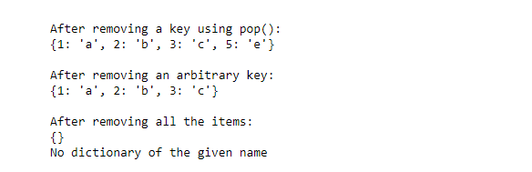

**For Replacing/Updating the data -**

**Code for Experiment :**

from collections import defaultdict

#Using loop

test_dict = {"Gfg" : 5, "is" : 8, "Best" : 10, "for" : 8, "Geeks" : 9}

print("The original dictionary is : " + str(test_dict))

updict = {"Gfg" : 10, "Best" : 17}

for sub in test_dict:

if sub in updict:

test_dict[sub] = updict[sub]

print("The updated dictionary using loop is: " + str(test_dict))

#Using dictionary comprehension

updict = {"Gfg" : 15, "Best" : 23}

res = {key: updict.get(key, test_dict[key]) for key in test_dict}

print("The updated dictionary using dictionary comprehension is: " + str(res))

updict = {"Gfg" : 20, "Best" : 27}

test_dict.update(updict)

print("The updated dictionary using dict.update() method is: " + str(test_dict))

#Using dict.update

updict = {"Gfg": 10, "Best": 17}

updated_values = map(

lambda key: updict[key] if key in updict else test_dict[key], test_dict)

updated_dict = dict(zip(test_dict.keys(), updated_values))

test_dict = {"Gfg": 5, "is": 8, "Best": 10, "for": 8, "Geeks": 9}

updict = {"Gfg": 25, "Best": 33}

#Using built-in map() function and a lambda function

updated_values = map(

lambda key: updict[key] if key in updict else test_dict[key], test_dict)

updated_dict = dict(zip(test_dict.keys(), updated_values))

print("The updated dictionary using the built-in map() function and a lambda function is: " + str(updated_dict))

#Using defaultdict

default_dict = defaultdict(lambda: None, test_dict)

updict = {"Gfg": 30, "Best": 37}

for key, value in updict.items():

default_dict[key] = value

updated_dict = dict(default_dict)

print("The updated dictionary using defaultdict is: " + str(updated_dict))

**Result/Output :**

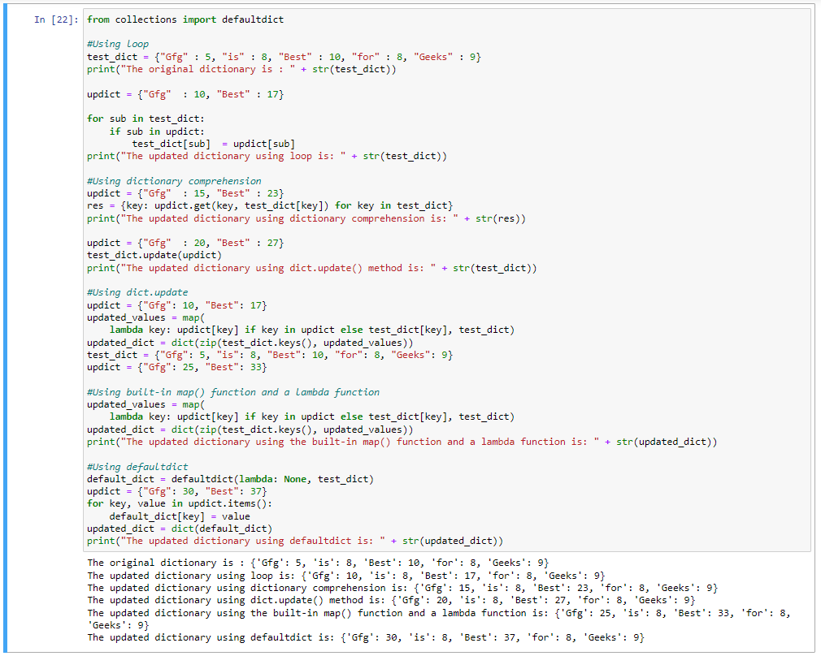

1. CREATE DICTIONARY WITH POSITIVE AND NEGATIVE NUMBERS OF LIST:

# Count positive and negative numbers in List

# Create a List

List1 = [10, -21, 4, -45, 66, -93, 1]

positive=0

negative=0

# Iterating each number in list

for num in List1:

    if num >= 0:

        positive = positive + 1

    else:

        negative = negative + 1

# Creating an empty Dictionary

DictC1 = {}

# Adding elements in Dictionary

DictC1['Positive'] = positive

DictC1['Negative'] = negative

print("List: ",List1)

print("\nDictionary: ",DictC1)

print()

**Result/Output :**

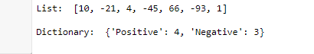

**Learning outcomes (What I have learnt):**

1. I learnt about the python language and its basic syntax.
2. I learnt about how create a dictionary in python.
3. I learnt about how to traverse and add items in dictionary.
4. I learnt about how to replace and delete items in dictionary.
5. I learnt about different inbuilt functions for dictionary..

**Evaluation Grid (To be created as per the SOP and Assessment guidelines by the faculty):**

|  |  |  |  |
| --- | --- | --- | --- |
| **Sr. No.** | **Parameters** | **Maximum Marks** | **Marks Obtained** |
| **1.** | **Student Performance**  **(Conduct of experiment)**  **Objectives/Outcomes.** | 12 |  |
| **2.** | **Viva Voce** | 10 |  |
| **3.** | **Submission of Work Sheet**  **(Record)** | 8 |  |